BICC SCHOOL HOLIDAY MOVIES



WEEK 1 - 3RD APRIL – 6TH APRIL

[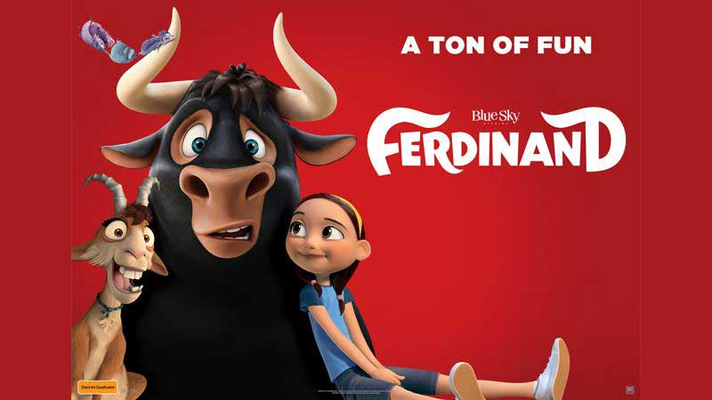](https://www.google.com.au/url?sa=i&rct=j&q=&esrc=s&source=images&cd=&cad=rja&uact=8&ved=2ahUKEwiSztXQwLXZAhXHm5QKHZS4BIwQjRx6BAgAEAY&url=https%3A%2F%2Fbabygizmo.com%2Fmovie-review-ferdinand%2F&psig=AOvVaw1w9e_NWWgll3pYGpSiVwp-&ust=1519250846034642)

[](https://www.google.com.au/url?sa=i&rct=j&q=&esrc=s&source=images&cd=&ved=2ahUKEwjQuu_lwLXZAhXFpZQKHQ3dADMQjRx6BAgAEAY&url=https%3A%2F%2Fwww.foxmovies.com%2Fmovies%2Fmaze-runner-the-death-cure&psig=AOvVaw08rmt5NUxRs1Bw3TIkOPXZ&ust=1519250899815059)

BICC SCHOOL HOLIDAY MOVIES



WEEK 2 – 9th APRIL – 13th  APRIL

[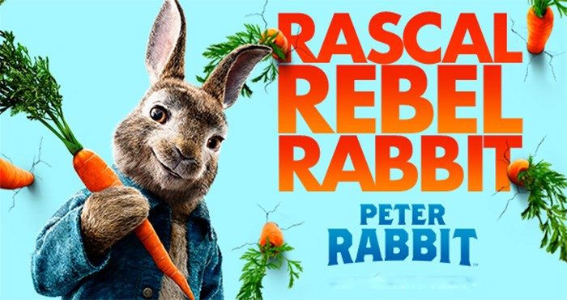](https://www.google.com.au/url?sa=i&rct=j&q=&esrc=s&source=images&cd=&cad=rja&uact=8&ved=2ahUKEwjesuLpw7XZAhWLFZQKHbueC0QQjRx6BAgAEAY&url=http%3A%2F%2Fsplashreport.com%2Ffilm-review-peter-rabbit%2F&psig=AOvVaw0nQ20aC--pspkp4Yaiil0K&ust=1519251715426329)

[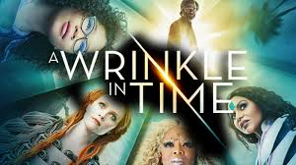](https://www.google.com.au/url?sa=i&rct=j&q=&esrc=s&source=images&cd=&cad=rja&uact=8&ved=2ahUKEwiXsJWBxLXZAhUGkpQKHXOQBncQjRx6BAgAEAY&url=http%3A%2F%2Fwww.thehollywoodnews.com%2F2018%2F01%2F03%2Fa-wrinkle-in-time-motion-posters%2F&psig=AOvVaw2FXk5mJ67hcI9b1vY7UzAb&ust=1519251745493198)