BICC Movie Time Table

Week 1, 18th – 22 Sept

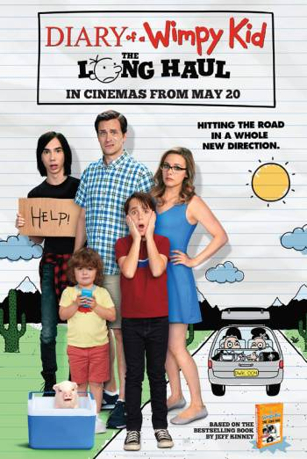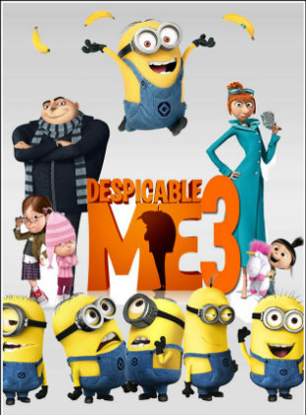  
**Despicable Me 3 Rating: PG Run Time:96 min**

The mischievous Minions hope that Gru will return to a life of crime after the new boss of the Anti-Villain League fires him. Instead, Gru decides to remain retired and travel to Freedonia to meet his long-lost twin brother for the first time. The reunited siblings soon find themselves in an uneasy alliance to take down the elusive Balthazar Bratt, a former 1980s child star who seeks revenge against the world.

**Diary of a Wimpy Kid – The Long Haul Rating: PG Run Time:91 min**

Young Greg Heffley is looking forward to a long summer of just hanging out, but his mother throws a monkey wrench into his plans when she forces the entire family to take a road trip for a relative's birthday celebration. His eyes soon light up after he realizes that the excursion is his ticket to a gaming convention to meet YouTube sensation Mac Digby. Greg's imagination then kicks into overdrive as he sneakily hatches a scheme to attend the expo and gain some much-deserved fame.

|  |  |  |  |  |  |
| --- | --- | --- | --- | --- | --- |
| **Session Times** | **Monday**  **18th Sept** | **Tuesday**  **19th Sept** | **Wednesday**  **20th Sept** | **Thursday**  **21st Sept** | **Friday**  **22nd Sept** |
| 10am | Despicable Me | Diary of a  Wimpy Kid | Despicable Me | Diary of a  Wimpy Kid | Despicable Me |
| 1pm | Diary of a  Wimpy Kid | Despicable Me | Diary of a  Wimpy Kid | Despicable Me | Diary of a  Wimpy Kid |

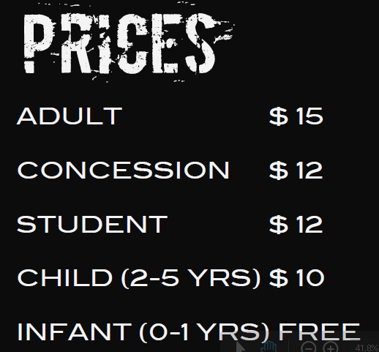

BICC Movie Time Table

Week 2, 25th – 29 Sept

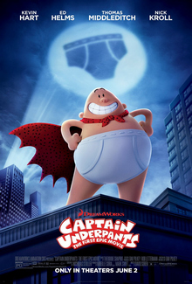

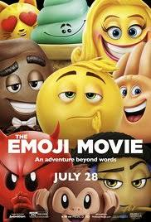

**Captain Underpants Rating: PG Run Time:96 min**

Two overly imaginative pranksters named George and Harold hypnotize their principal into thinking he's a ridiculously enthusiastic, incredibly dimwitted superhero named Captain Underpants.

**Emoji Movie Rating: PG Run Time:91 min**

Hidden inside a smartphone, the bustling city of Textopolis is home to all emojis. Each emoji has only one facial expression, except for Gene, an exuberant emoji with multiple expressions. Determined to become "normal" like the other emojis, Gene enlists the help of his best friend Hi-5 and a notorious code breaker called Jailbreak. During their travels through the other apps, the three emojis discover a great danger that could threaten their phone's very existence

|  |  |  |  |  |  |
| --- | --- | --- | --- | --- | --- |
| **Session Times** | **Monday**  **25th Sept** | **Tuesday**  **26th Sept** | **Wednesday**  **27th Sept** | **Thursday**  **28th Sept** | **Friday**  **29th Sept** |
| 10am | Captain Underpants | Emoji  Movie | Captain Underpants | Emoji  Movie | Captain Underpants |
| 1pm | Emoji  Movie | Captain Underpants | Emoji  Movie | Captain Underpants | Emoji  Movie |

